Install client “setup en-CA.exe” under:
\\erp01\Public\FS NAV\Nav 5 SP1\CsideClient
Install ExpandIt client (logoff timer) under :
\\erp01\Public\Expandit Client Control
after the install, you must copy the file ecc.reg to the PC and execute it.

The shortcut to launch the application is:
“Microsoft SQL Server Option for the CSIDE Client”

Database info :
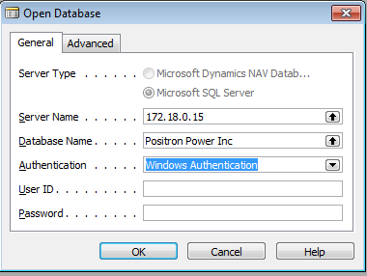
Monique needs to create the roless before a user can connect.
After the roles are created, need to login with “SA” and do a “synchronize login”
Natalie Train or June Cotty can do it if nobody is available.

Maintenance.
The way the consultants configured the server, it generates big backup files, every month, need to delete files under:
F:\Navision SQL Backups\Positron Power Inc
(I usually keep no more than 10 days)
If the files are not deleted, the F drive gets full and NAV will complain about DB issue

